**BED Assignment Instructions**

1. Open the folder DIT/1B/06_P1935657_SaraGolkaran_Assigment in Visual Studio Code
2. Import snapsell.sql into the sql workbench
3. On the terminal, cd to this folder and run “nodemon server.js” on terminal
4. Proceed to Postman and create endpoints

First endpoint: eg <http://localhost:3000/users>. Using GET request to retrieve all users. For example, the outcome should be

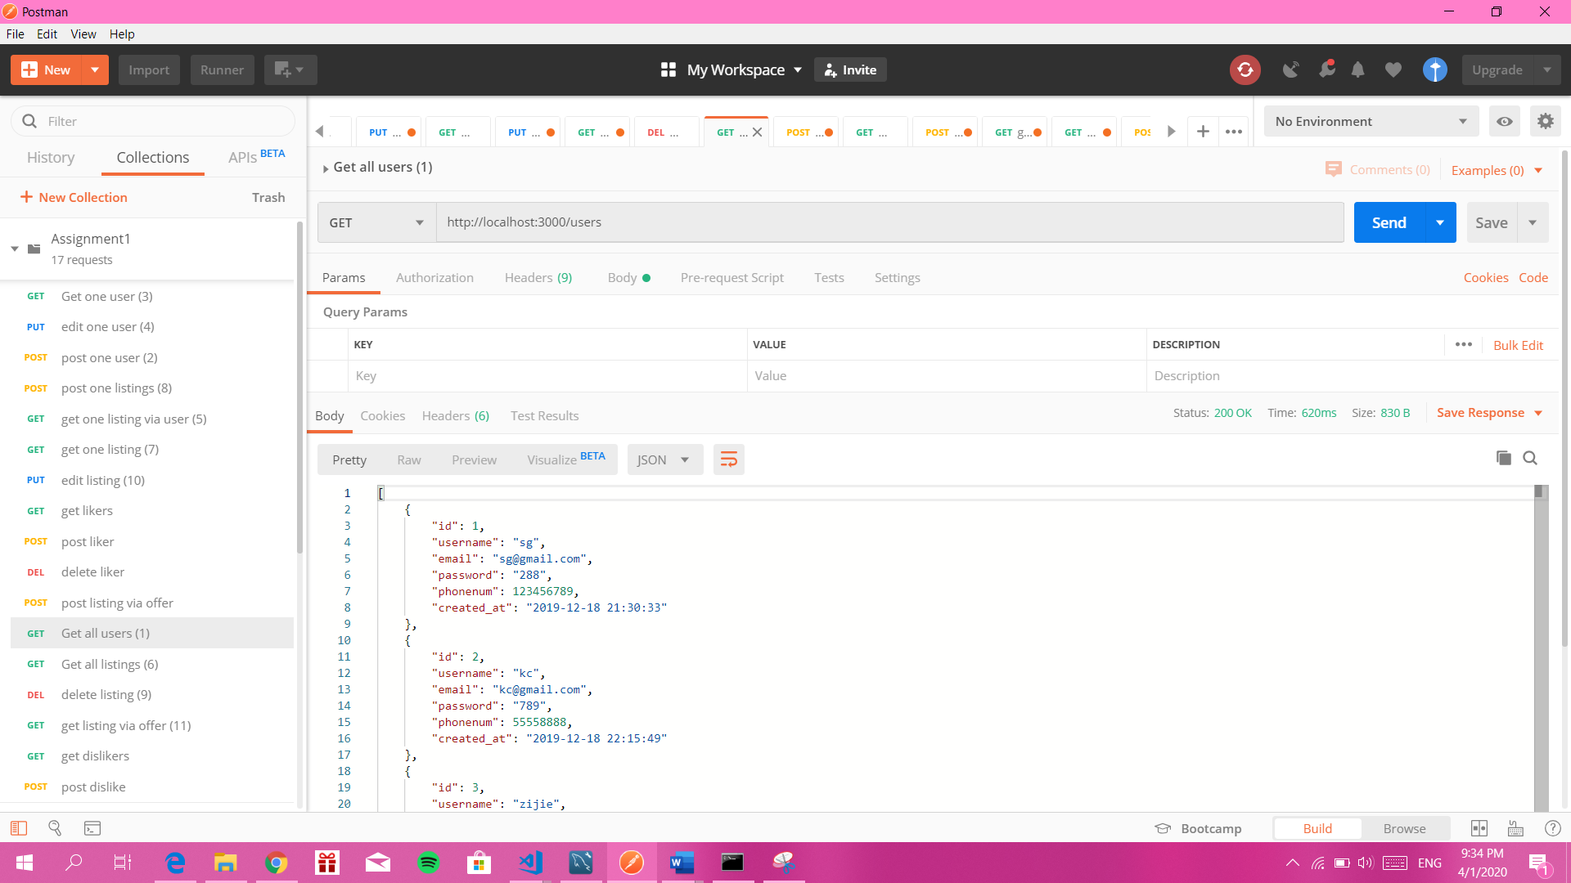

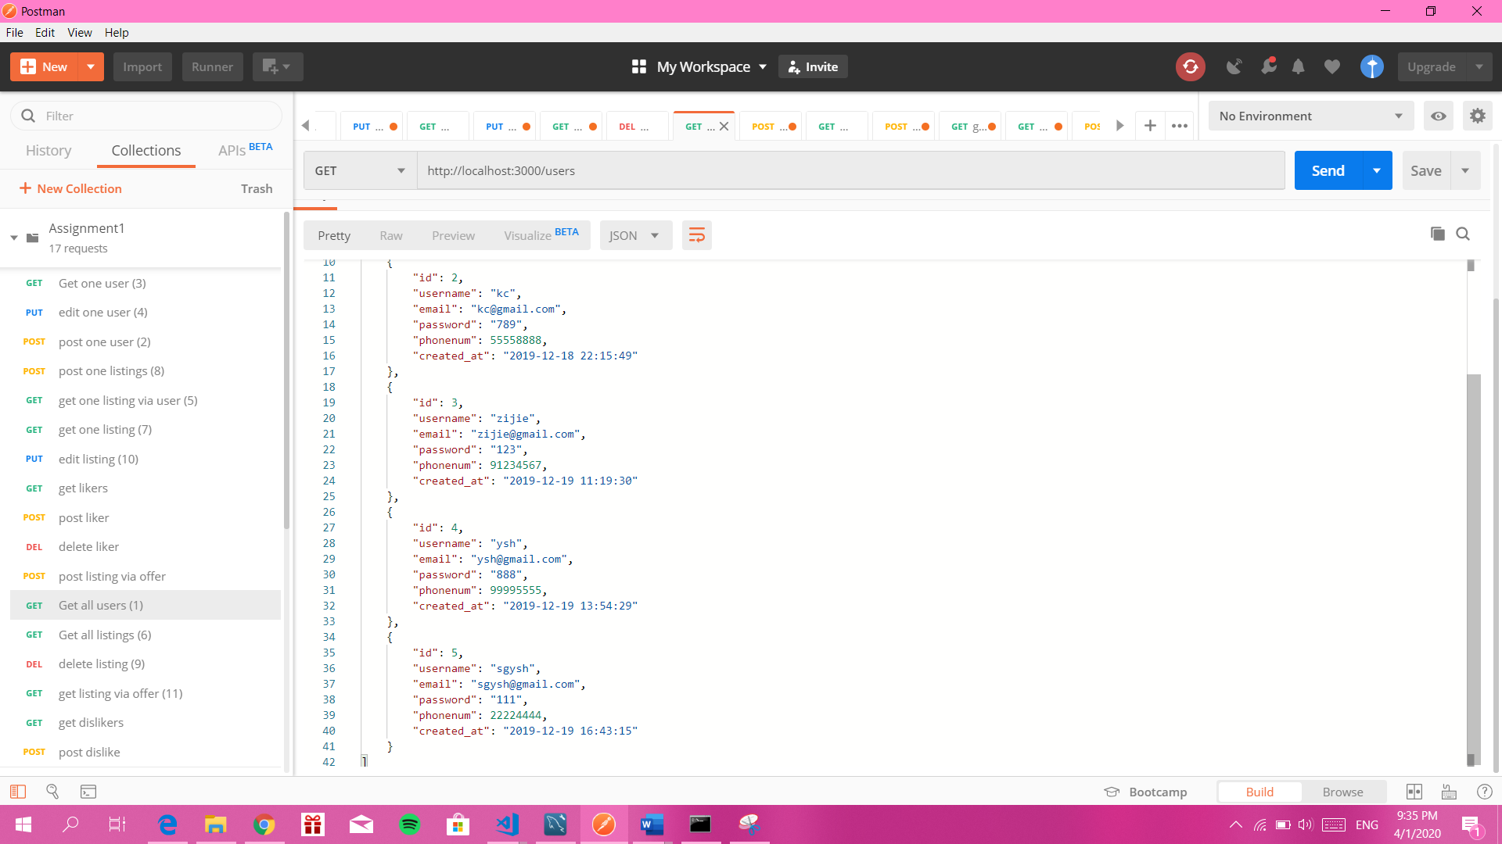

Second endpoint: eg <http://localhost:3000/users>. Using POST to add one user. For example, the outcome should be

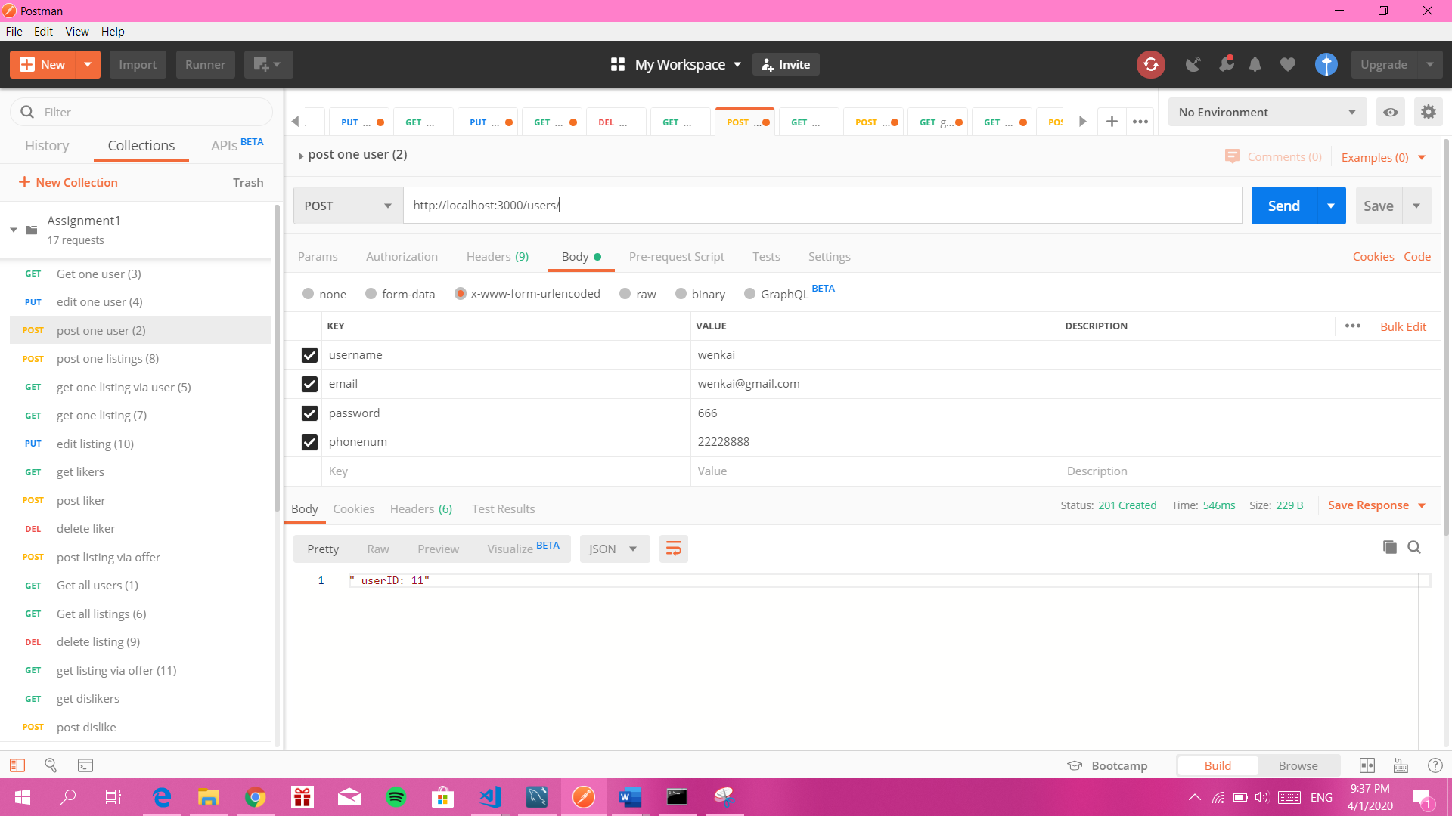

Third endpoint: eg <http://localhost:3000/users/3>. Using GET to retrieve one user. For example, the outcome should be

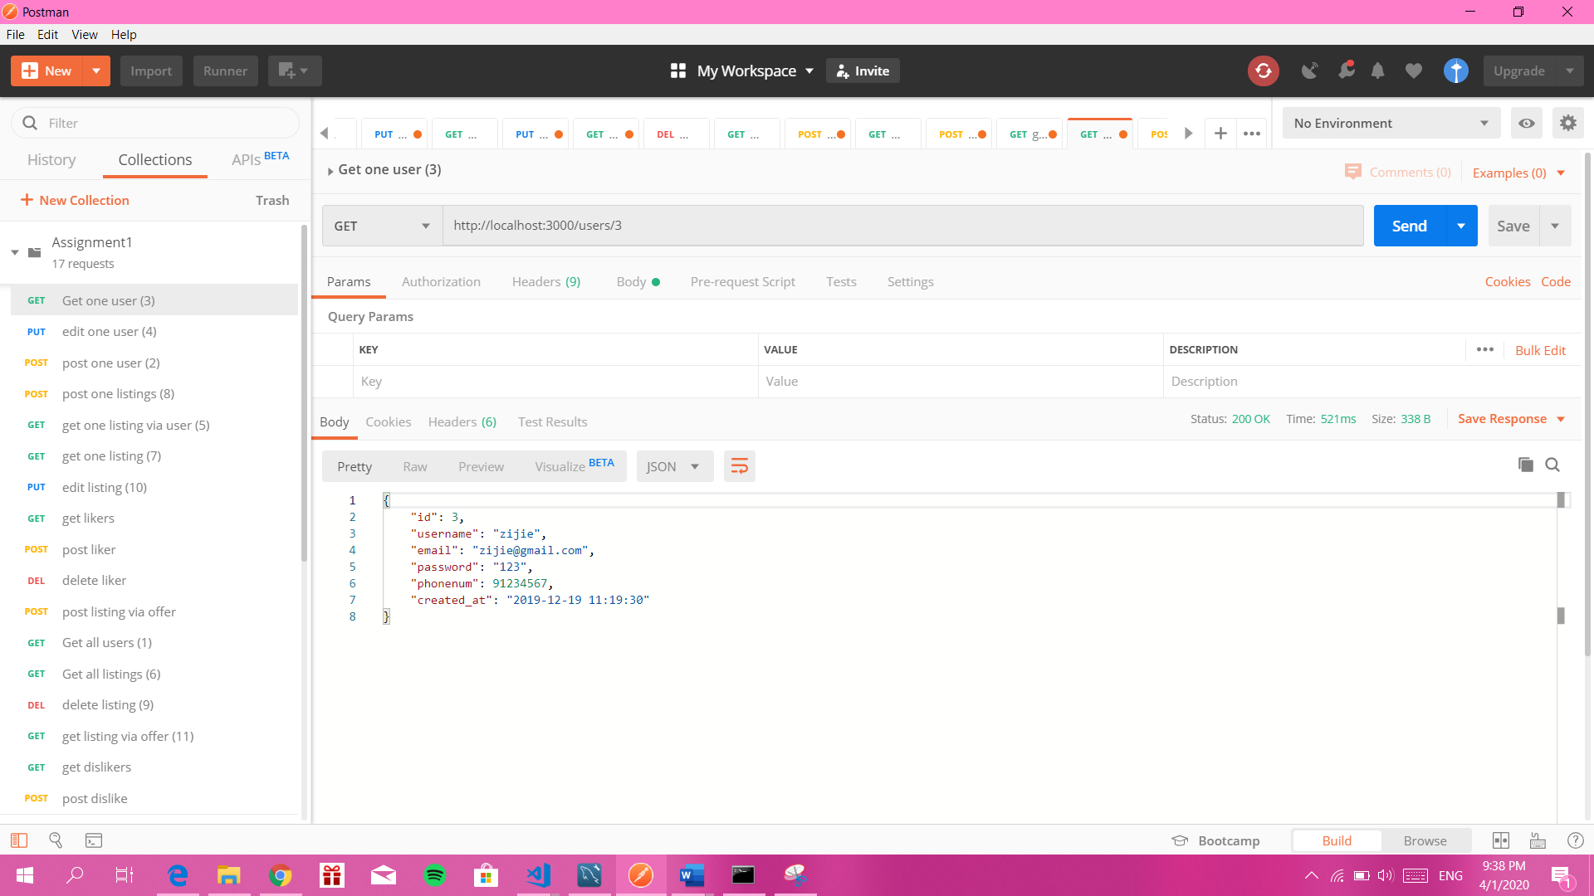

Fourth endpoint: eg <http://localhost:3000/users/11>. Using PUT to edit one user. For example, the outcome should be

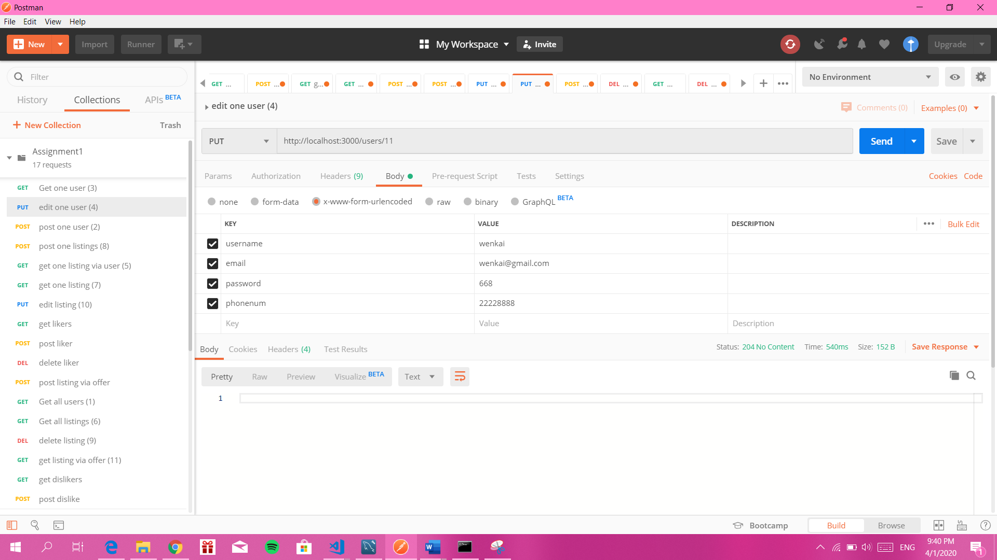

Fifth endpoint: eg <http://localhost:3000/users/1listings>. Using GET to retrieve all listings by a given user. For example, the outcome should be

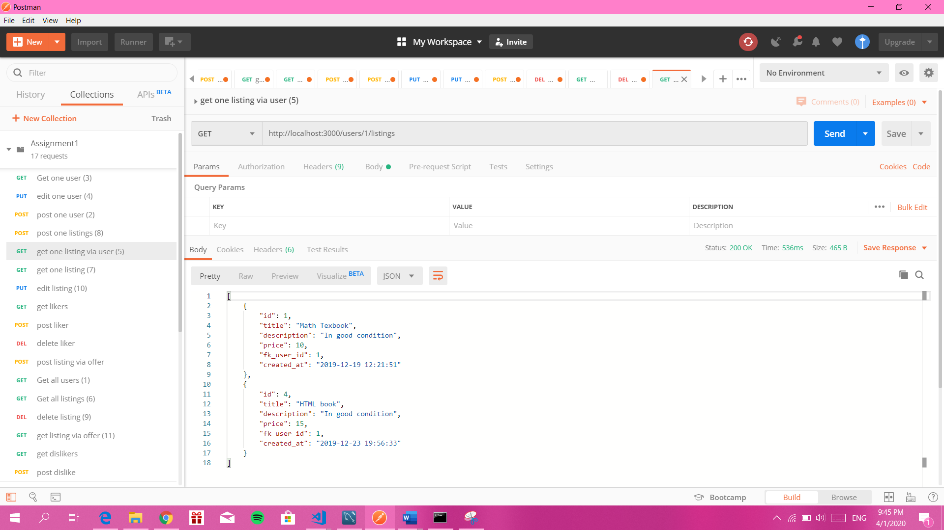

Sixth endpoint: eg <http://localhost:3000/listings>. Using GET to retrieve all listings

For example, the outcome should be

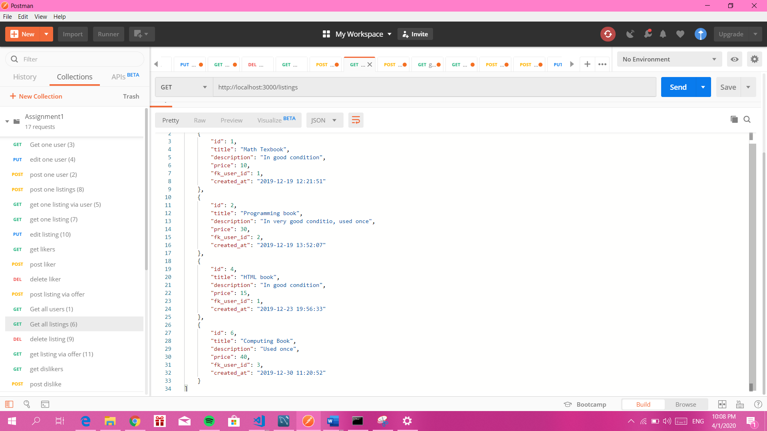

Seventh endpoint: eg <http://localhost:3000/listings>. Using GET to retrieve a single listing by its id. For example, the outcome could be

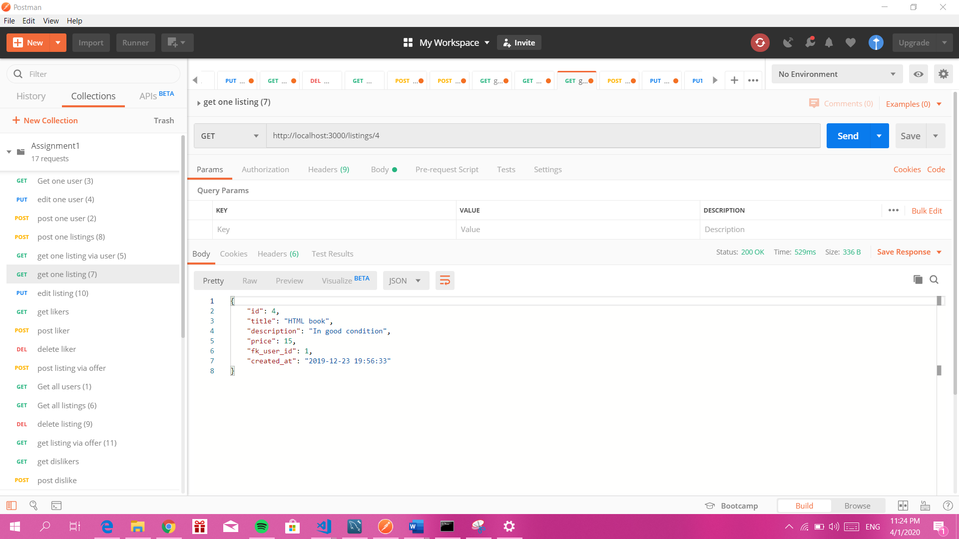

Eighth endpoint: eg <http://localhost:3000/listings>. Use POST to add a new listing to the database. For example, the outcome could be

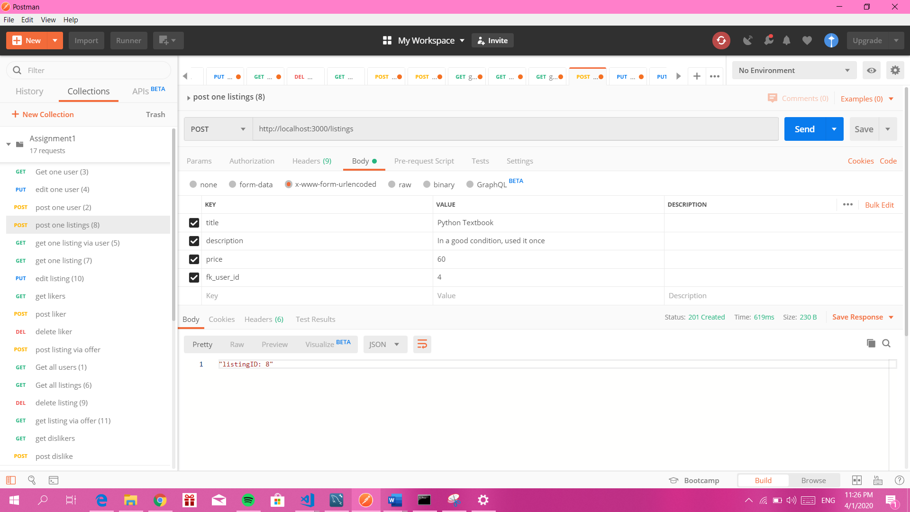

Ninth endpoint: eg <http://localhost:3000/listings/9>. Use DELETE to delete a listing

For example, the outcome could be

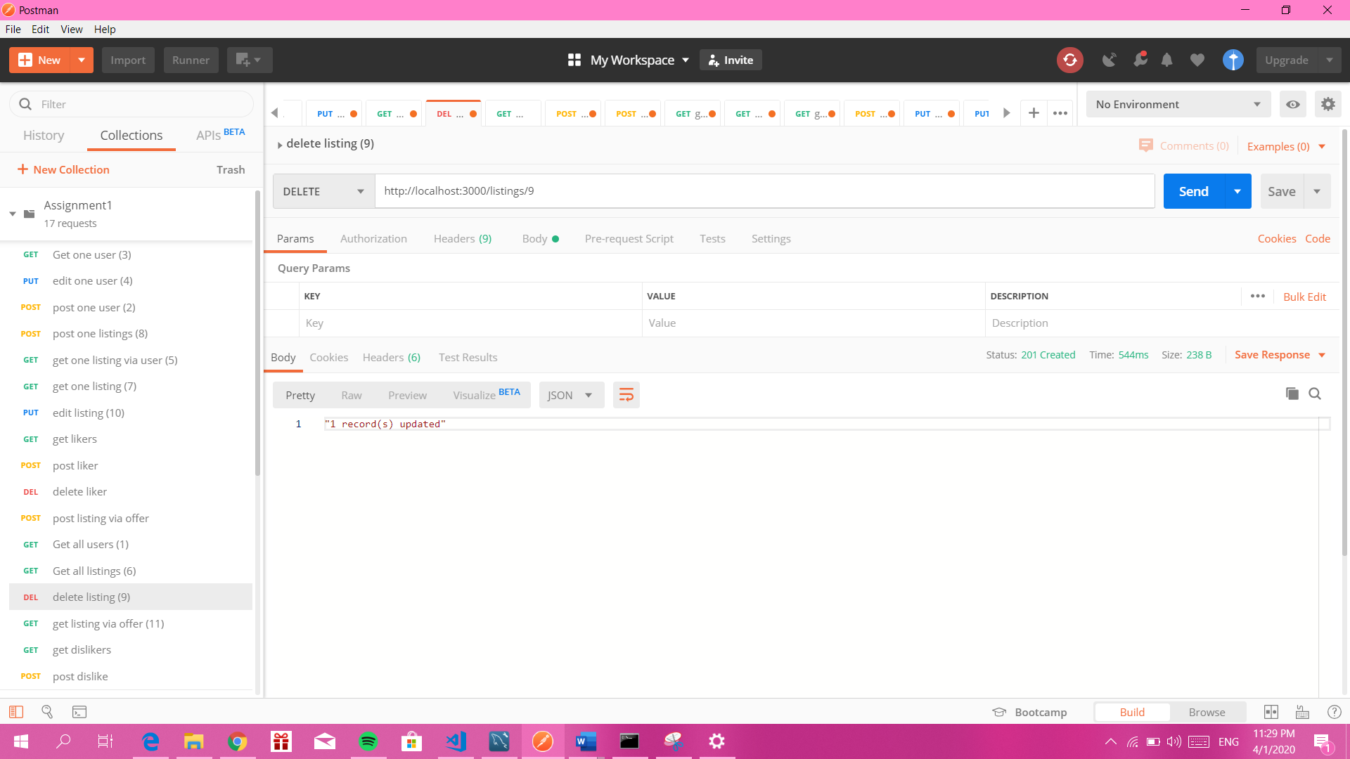

Tenth endpoint: eg <http://localhost:3000/listings/7>. Use PUT to update a listing.

For example, the outcome could be

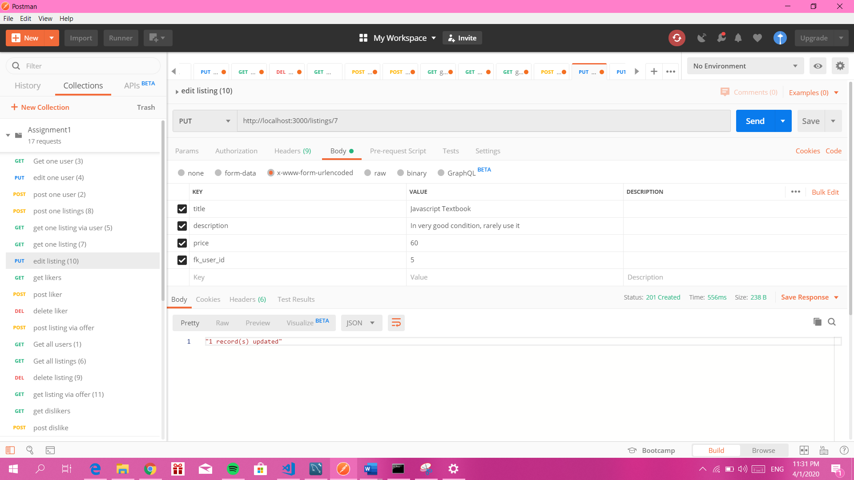

Eleventh endpoint: eg http://localhost:3000/2/offers

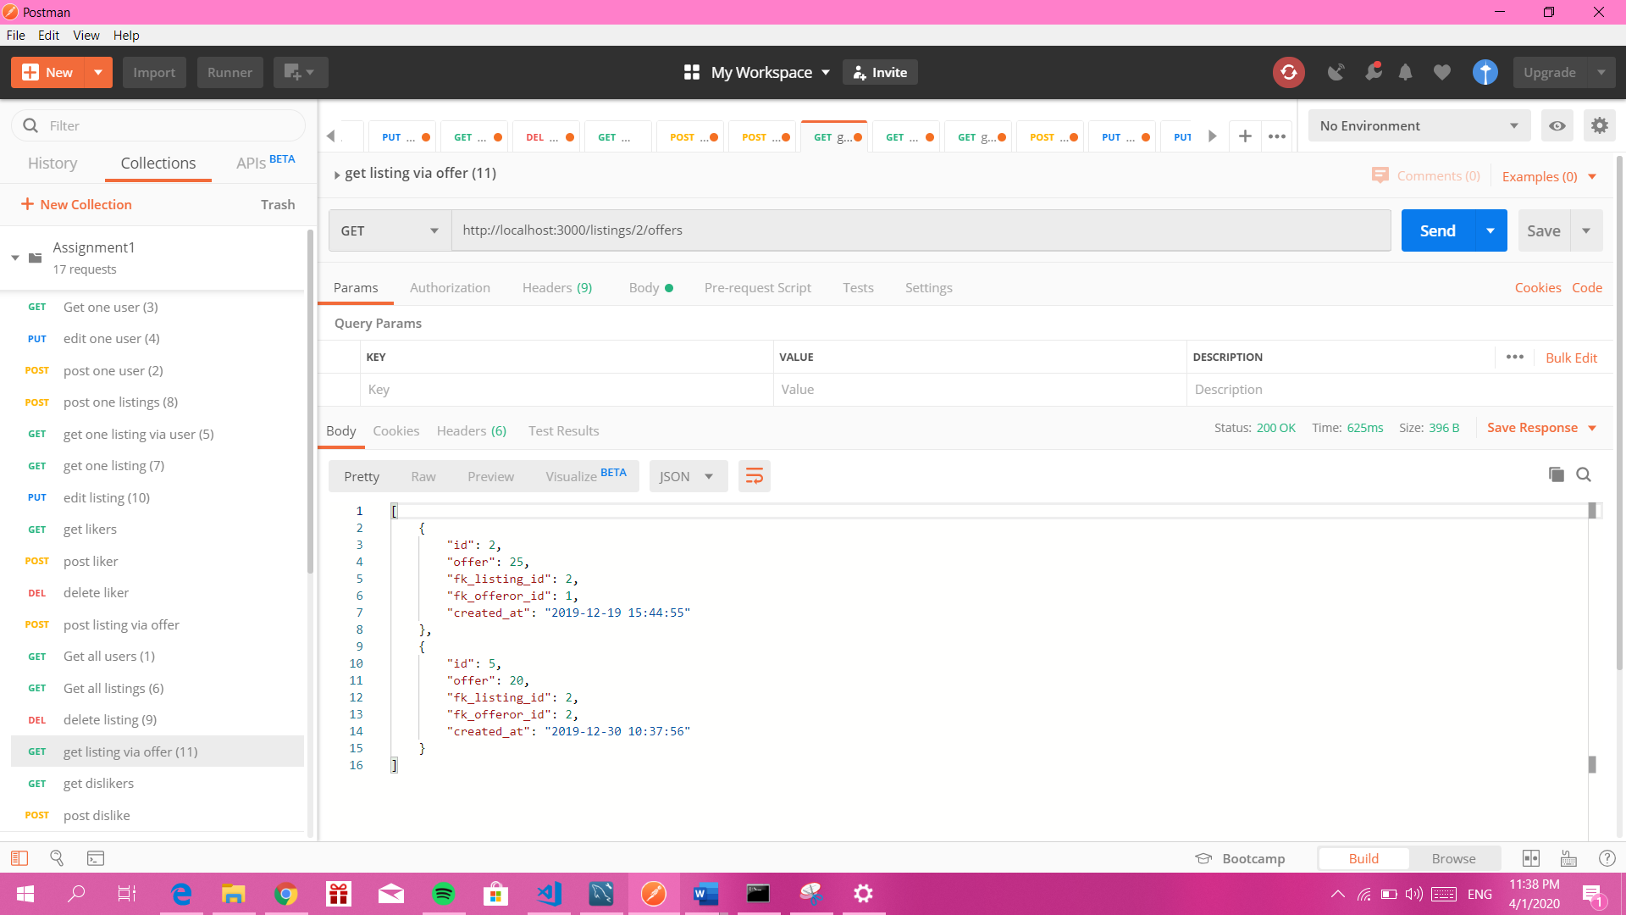

Twelfth endpoint: eg <http://localhost:3000/listings/7/offers>. Use POST to add an offer to the listing. For example, the outcome should be

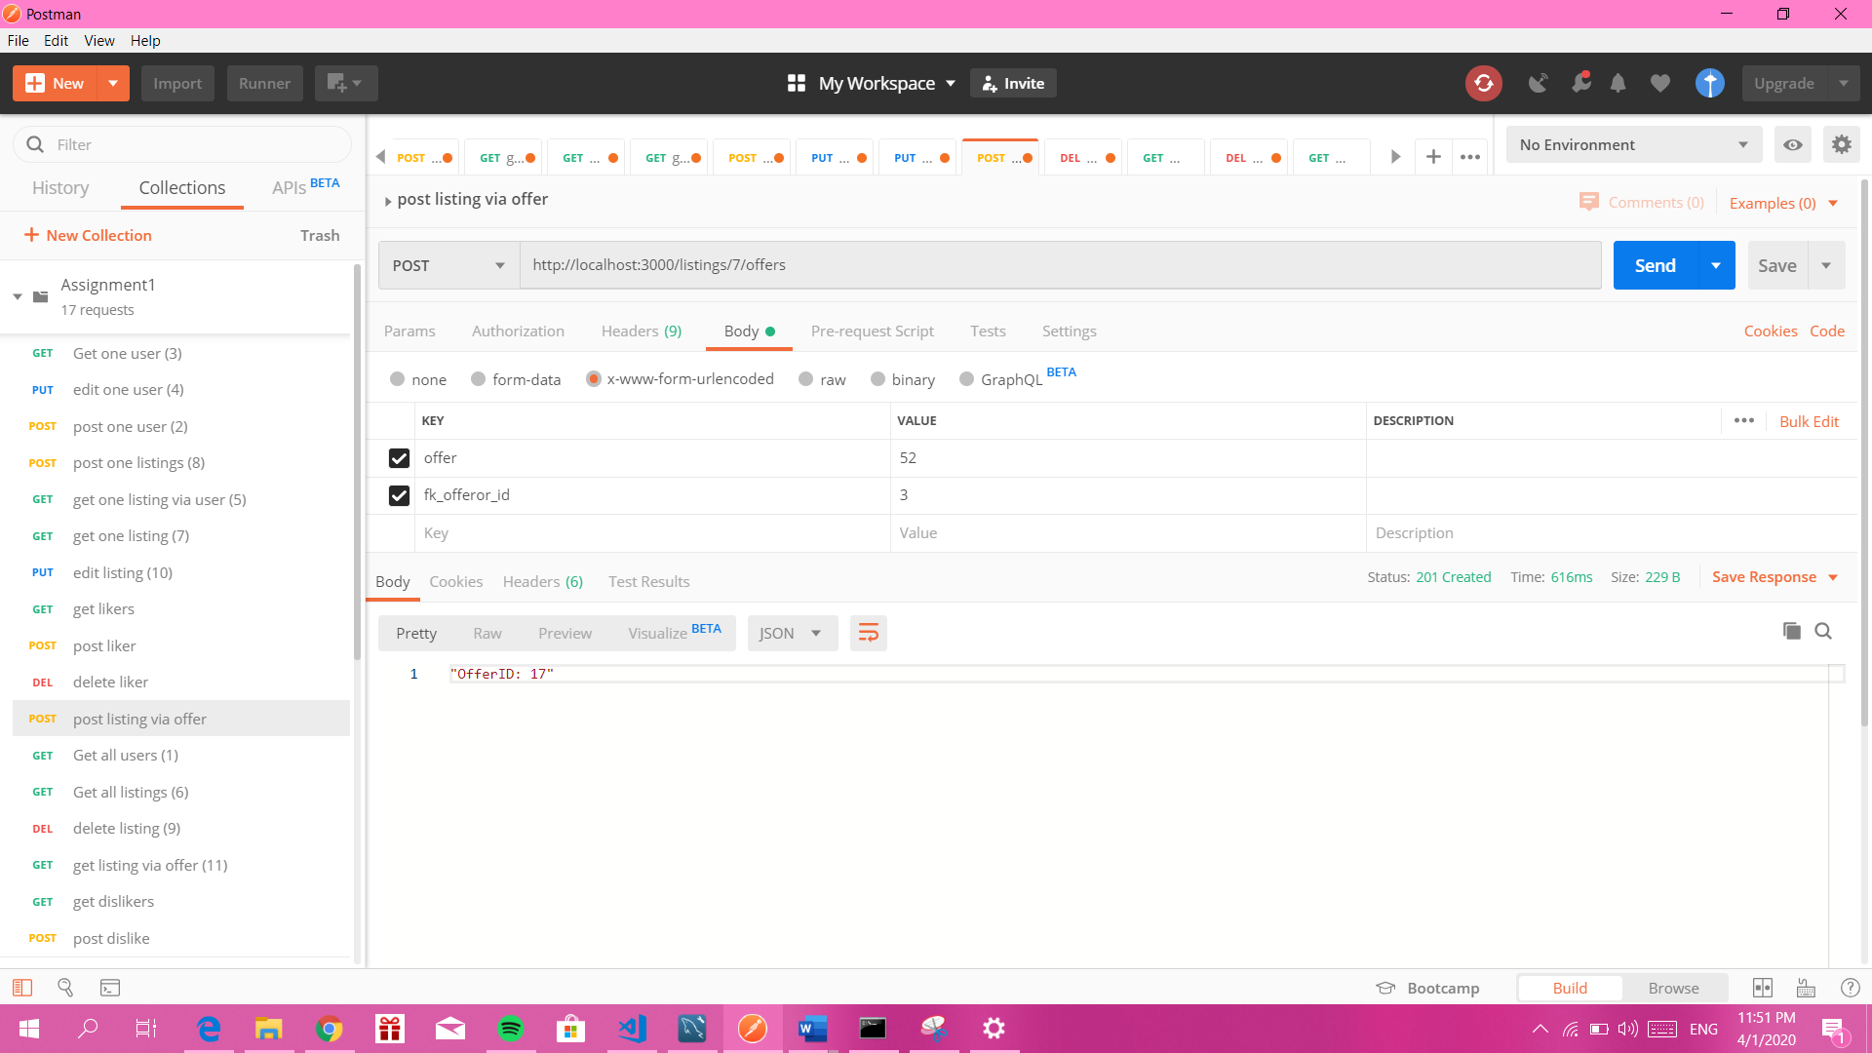

**Advanced Features for Likes and Dislikes**

Eg <http://localhost/listings/6/likes>. Use GET to retrieve all likers

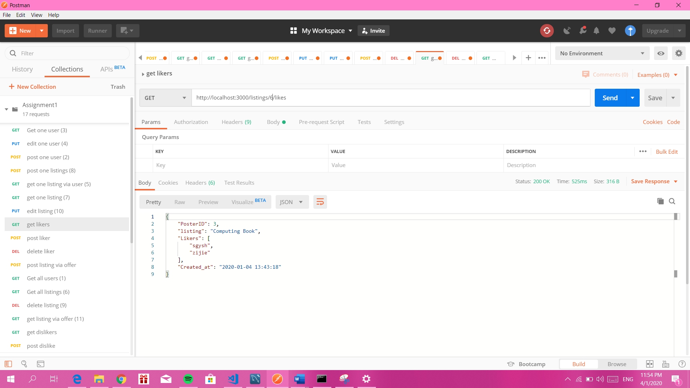

Eg <http://localhost:3000/likes>. Use POST to post one like. For example the outcome could be

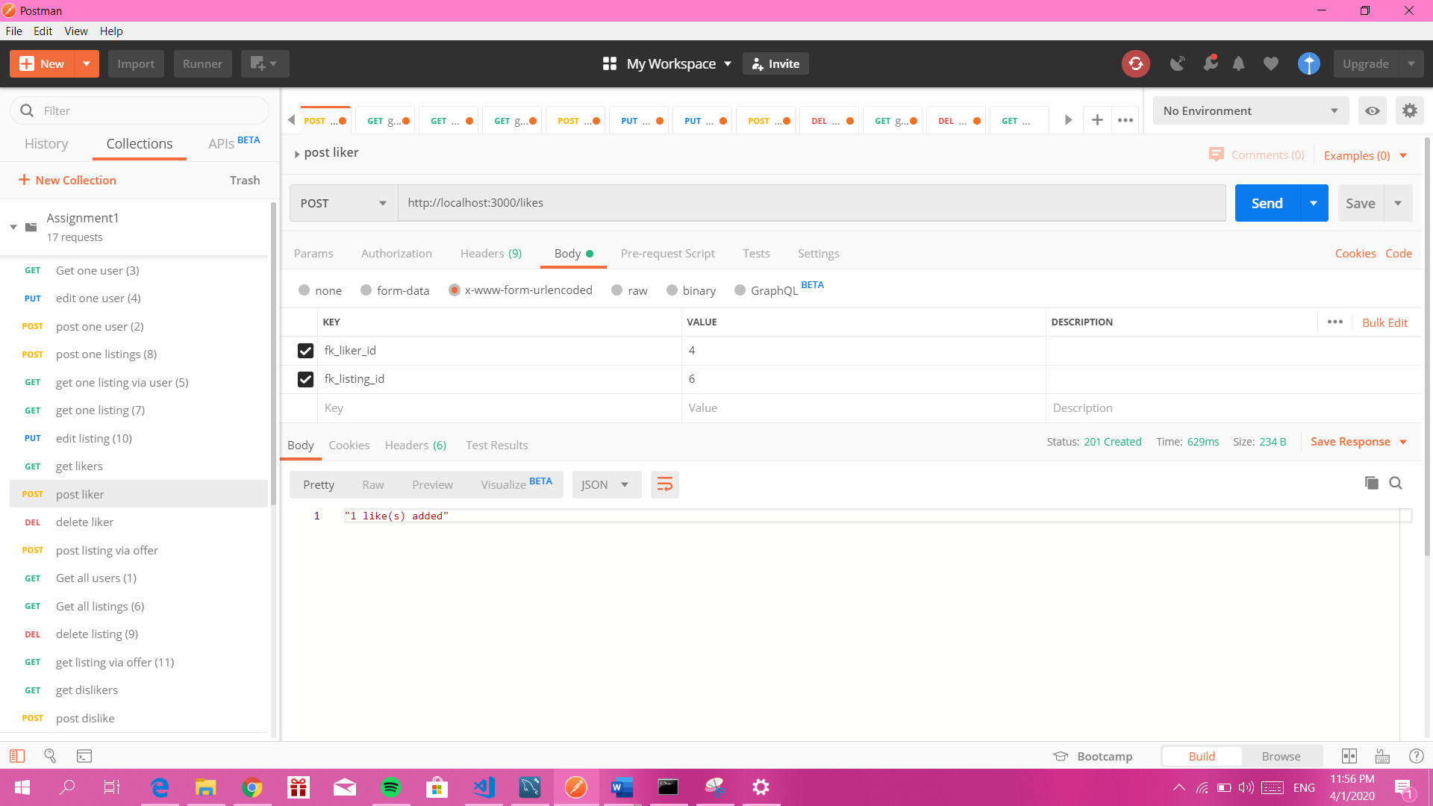

Eg: <http://localhost:3000/likes>. Use DELETE to delete one like.

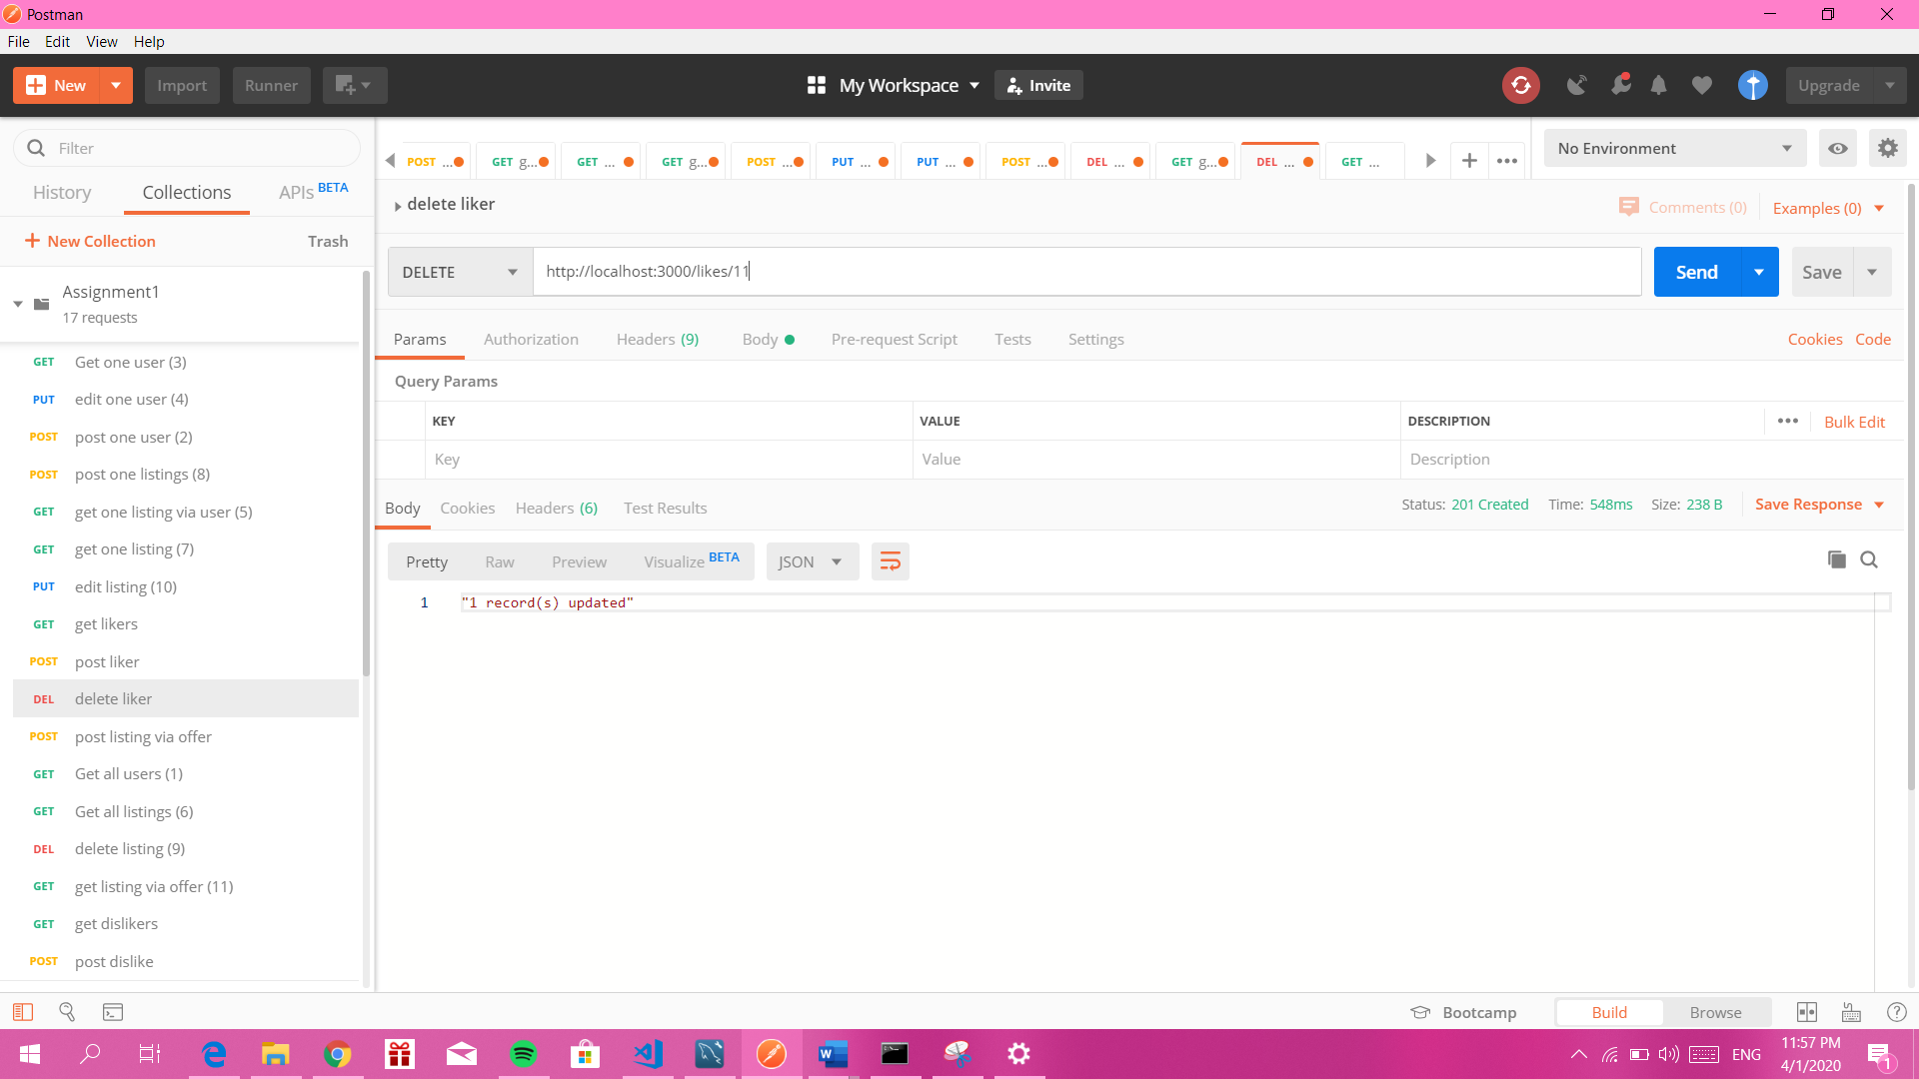

Eg <http://localhost:3000/2/dislikes>. Use GET to retrieve all dislikes that dislike certain listing

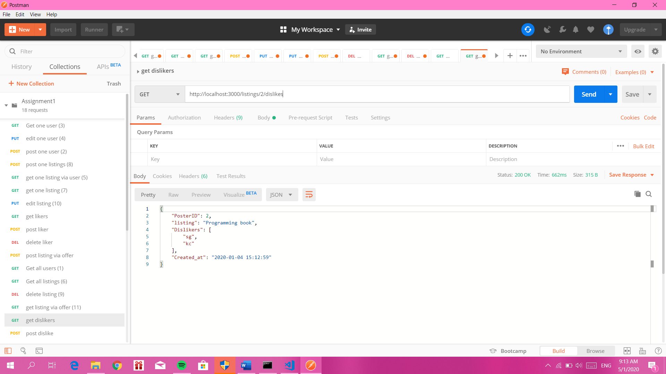

Eg <http://localhost:3000/dislikes>. Use POST to post one dislike

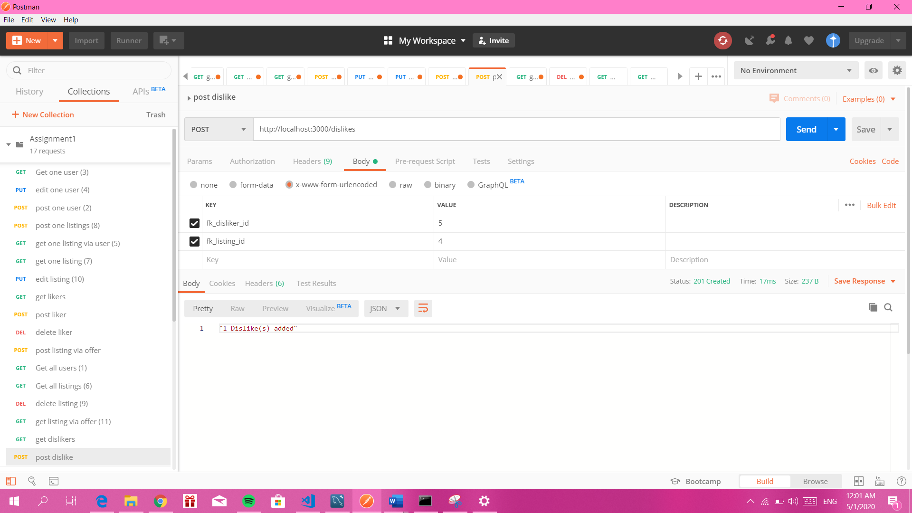

Eg <http://localhost:3000/dislike/20>. Use DELETE to delete one dislike.

